Host Discovery
When we need to conduct an internal penetration test for the entire network of a company, for example, then we should, first of all, get an overview of which systems are online that we can work with.
To actively discover such systems on the network, we can use various Nmap host discovery options. There are many options Nmap provides to determine whether our target is alive or not.
The most effective host discovery method is to use ICMP echo requests, which we will look into.
It is always recommended to store every single scan. This can later be used for comparison, documentation, and reporting. After all, different tools may produce different results. Therefore it can be beneficial to distinguish which tool produces which results.
Scan Network Range
sudo nmap 10.129.2.0/24 -sn -oA tnet | grep for | cut -d" " -f5
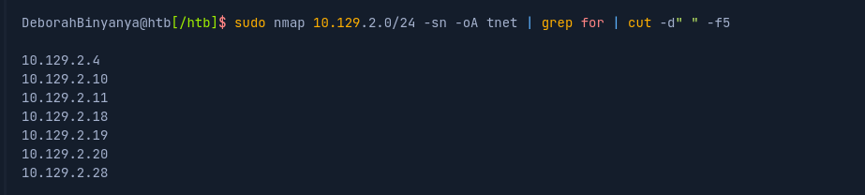
Scanning Options | Description
10.129.2.0/24 | Target network range.
-sn | Disables port scanning.
-oA tnet | Stores the results in all formats starting with the name 'tnet'.
This scanning method works only if the firewalls of the hosts allow it. Otherwise, we can use other scanning techniques to find out if the hosts are active or not. Scan IP List
During an internal penetration test, it is not uncommon for us to be provided with an IP list with the hosts we need to test. Nmap also gives us the option of working with lists and reading the hosts from this list instead of manually defining or typing them in.

For example if given a list of addresses maybe saved In hosts.lst
You can open the file to view the IP addresses using the “cat” command:
cat hosts.lst
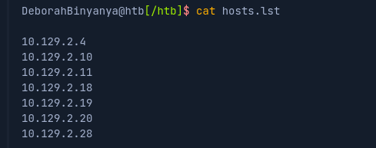

If we use the same scanning technique on the predefined list, the command will look like this:
sudo nmap -sn -oA tnet -iL hosts.lst | grep for | cut -d" " -f5
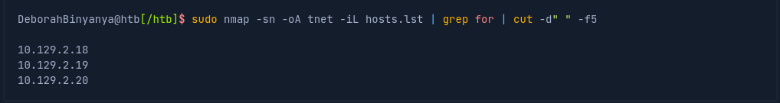

Scanning Options | Description
-sn | Disables port scanning.
-oA tnet | Stores the results in all formats starting with the name 'tnet'.
-iL | Performs defined scans against targets in provided 'hosts.lst' list.
In this example, we see that only 3 of 7 hosts are active. Remember, this may mean that the other hosts ignore the default ICMP echo requests because of their firewall configurations. Since Nmap does not receive a response, it marks those hosts as inactive.

Scan Multiple Ips
It can also happen that we only need to scan a small part of a network. An alternative to the method we used last time is to specify multiple IP addresses.
sudo nmap -sn -oA tnet 10.129.2.18 10.129.2.19 10.129.2.20| grep for | cut -d" " -f5
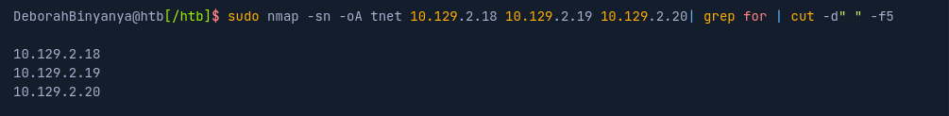
If these IP addresses are next to each other, we can also define the range in the respective octet.
sudo nmap -sn -oA tnet 10.129.2.18-20| grep for | cut -d" " -f5
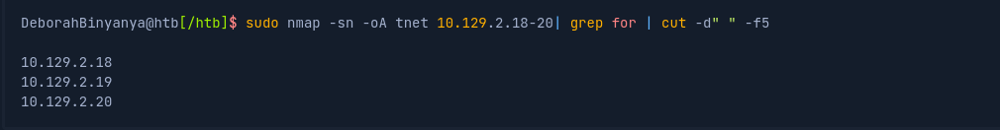
Command | Description
sudo | Runs the command with elevated privileges.
nmap -sn | Ping scan (host discovery only, no port scan).
-oA tnet | Outputs results in three formats (normal, XML, and grepable) with base filename tnet
10.129.2.18 10.129.2.19 10.129.2.20 | Target IPs.
| grep for | Filters lines containing the word "for" (e.g., "Host is up").
| cut -d" " -f5 | Extracts the fifth space-delimited field

Scan Single IP
Before we scan a single host for open ports and its services, we first have to determine if it is alive or not. For this, we can use the same method as before.
sudo nmap 10.129.2.18 -sn -oA host
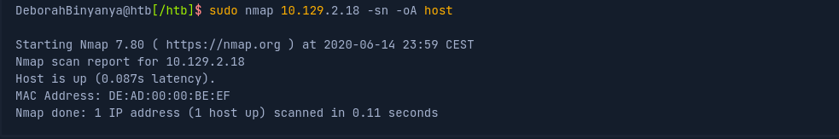
Scanning Options | Description
10.129.2.18 | Performs defined scans against the target IP.
-sn | Disables port scanning.
-oA host | Stores the results in all formats starting with the name 'host'.
If we disable port scan (-sn), Nmap automatically ping scan with ICMP Echo Requests (-PE). Once such a request is sent, we usually expect an ICMP reply if the pinging host is alive. The more interesting fact is that our previous scans did not do that because before Nmap could send an ICMP echo request, it would send an ARP ping resulting in an ARP reply. We can confirm this with the "--packet-trace" option. To ensure that ICMP echo requests are sent, we also define the option (-PE) for this.
sudo nmap 10.129.2.18 -sn -oA host -PE --packet-trace
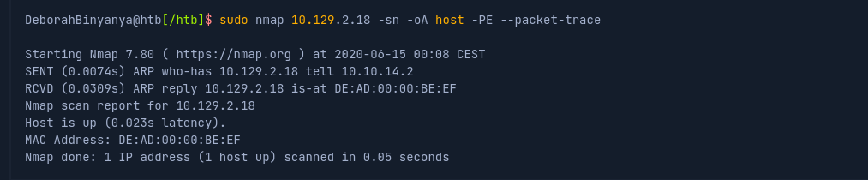
Scanning Options | Description
10.129.2.18 | Performs defined scans against the target.
-sn | Disables port scanning.
-oA host | Stores the results in all formats starting with the name 'host'.
-PE | Performs the ping scan by using 'ICMP Echo requests' against the target.
--packet-trace | Shows all packets sent and received
Another way to determine why Nmap has our target marked as "alive" is with the "--reason" option.
sudo nmap 10.129.2.18 -sn -oA host -PE --reason
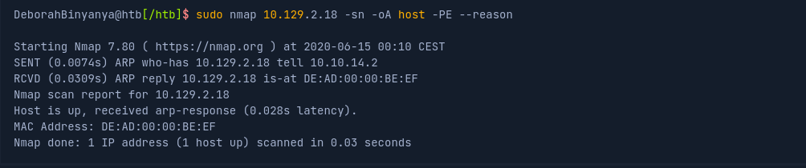

Scanning Options | Description
10.129.2.18 | Performs defined scans against the target.
-sn | Disables port scanning.
-oA host | Stores the results in all formats starting with the name 'host'.
-PE | Performs the ping scan by using 'ICMP Echo requests' against the target.
--reason | Displays the reason for specific result.
We see here that Nmap does indeed detect whether the host is alive or not through the ARP request and ARP reply alone. To disable ARP requests and scan our target with the desired ICMP echo requests, we can disable ARP pings by setting the "--disable-arp-ping" option. Then we can scan our target again and look at the packets sent and received.
sudo nmap 10.129.2.18 -sn -oA host -PE --packet-trace --disable-arp-ping
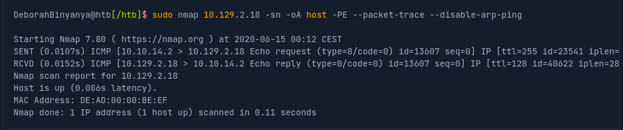
Question
Based on the last result, find out which operating system it belongs to. Submit the name of the operating system as result.
The key detail here is the Time To Live (TTL) value in the ICMP reply:
RCVD (0.0152s) ICMP [10.129.2.18 > 10.10.14.2 Echo reply (type=0/code=0) id=13607 seq=0] IP [ttl=128 id=40622 iplen=2
ttl=128
A TTL of 128 is characteristic of Windows operating systems.
Windows typically starts with TTL 128.
Linux/Unix systems usually start with TTL 64.
Cisco devices often use TTL 255.

Host and Port Scanning

